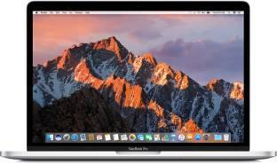

**www.PPCLandingPage.com**

**BUY A MACBOOK TODAY**

The MacBook is a Touch of Genius

**BROWSE MAC PRODUCTS AND PURCHASE TODAY**



On our website, we guarantee all year round quality offers on all the latest Luxury and High-Tech products out there. Our service enables you to purchase the best products at the most affordable prices. You can get the latest LCD screen, the latest smartphone or the latest video game console for only a few pounds. Terms and conditions